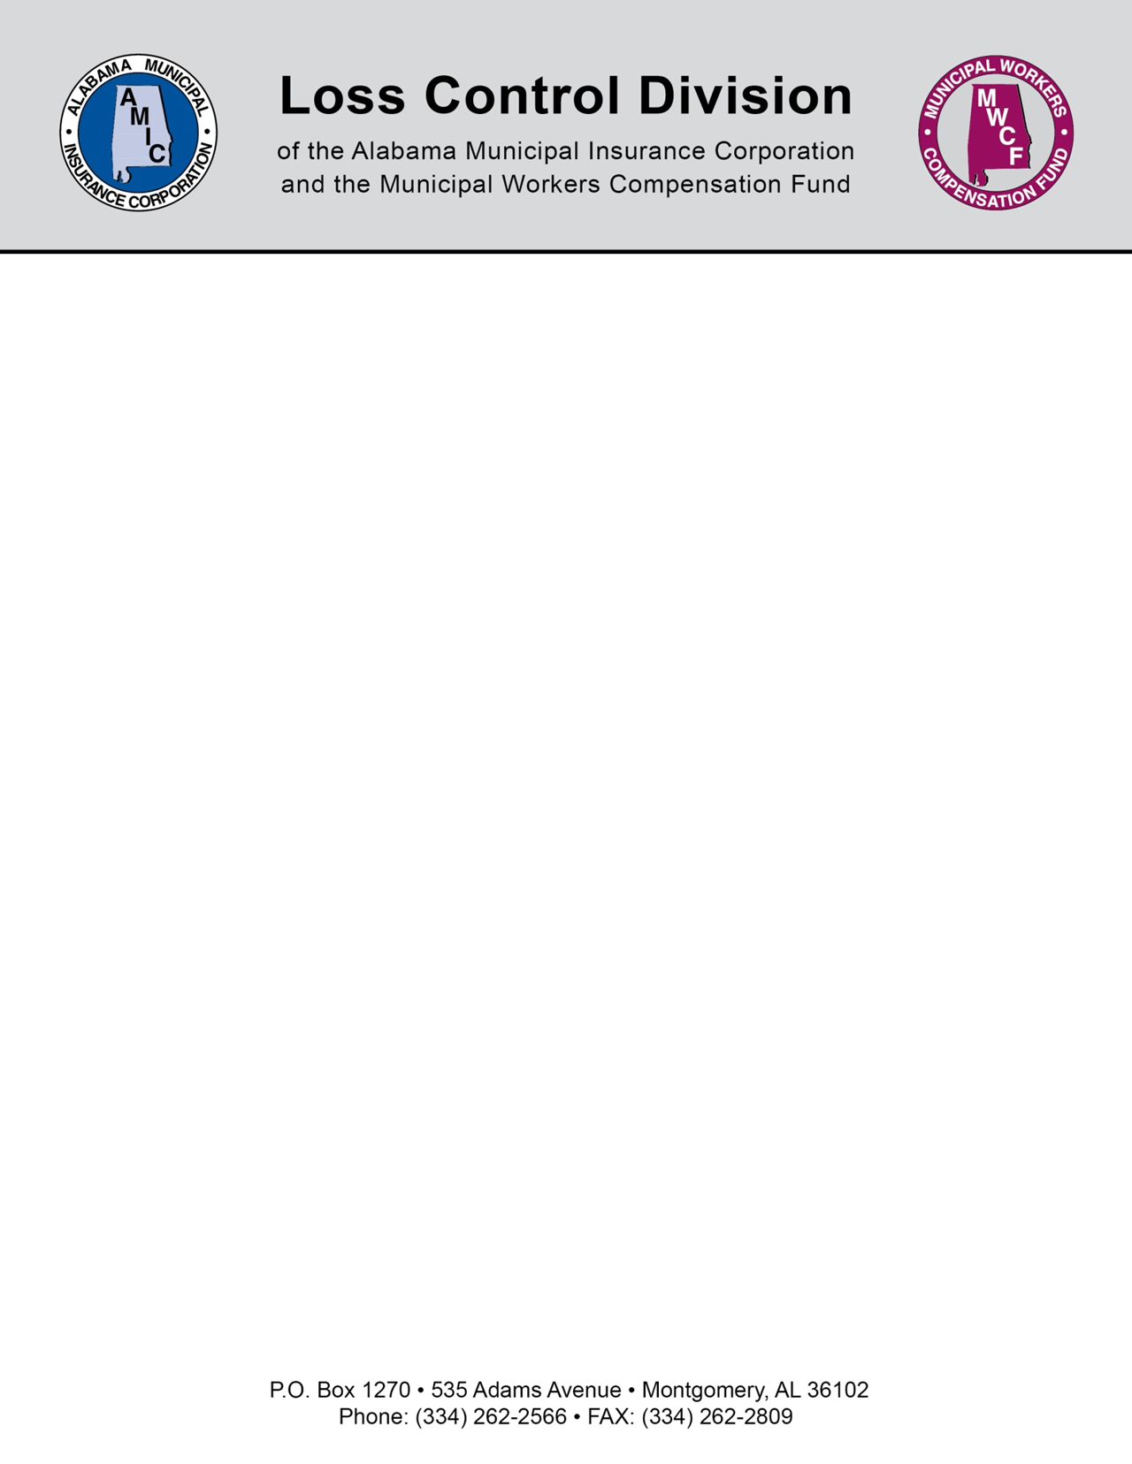

RECOMMENDATION RESPONSE FORM
Account: City of USA
Visit Date: January 1, 2026
Today’s Date: January 21, 2026
Loss Control Representative:
Recommendation Response Form Instructions
Download this Word document. If the Word document opens in Protected View, click Enable Editing.
Fill in the form by typing your responses. Typed responses allow us to accurately document your reply.
Please do not handwrite your responses.
Each recommendation includes a section that must be completed by the member, this section contains three fields. Follow the steps below:
Step one: Complete the Rec Response Code field by entering codes 1-5.

(1) Complete (4) Future Project
(2) Not Complete (5) Under Advisement
(3) In-process of Completing
Please fill in all Rec Response Code fields. Fields that are left blank will be considered Not Complete.
Step two: List the Rec Response Date. This field should be the date on which the recommendation was completed for response code 1. For response codes 2-5, please enter the date you are completing the form.
Step three: List any Rec Response Comments. This field is not required; however, it provides you with an opportunity to submit additional information concerning the recommendation.

Step four: Once the form is complete, attach the file and send it to losscontrol@almonline.org within 45 days. Do not attempt to embed the response form in the body of your email or send it as a zip file.
All responses will be documented in our database and will be considered during the underwriting process.
Submitted by:
Name / Title: ______________________________________________________
Date: _____________________________________________________________

Recommendations
Rec Number | Recommendation Title
2026-01-01 | Employee Safety: Safety Meetings: Recommended
Severity | Status
Best Practice | 2 - Not Completed
Recommendation
It is recommended that you conduct and document monthly safety meetings. Safety meetings allow all employees to voice any safety concerns they have, provide preventative safety training, and encourage employees to work safely. Our online training offered through LocalGovU is a good resource, provided to you at no cost, to assist you with conducting these meetings.
To be completed by Member
Rec Response Code | Rec Response Date
Rec Response Comments

Rec Number | Recommendation Title
2026-01-02 | Drug Testing: General
Severity | Status
Best Practice | 2 - Not Completed
Recommendation
It is recommended that your municipality establish a drug and alcohol testing policy. This policy is especially important in the police department but should be considered for all municipal employees. A drug and alcohol-testing program gives the public confidence that municipal employees are drug and alcohol free, while also helping to lower exposure to workers’ injuries and liabilities. This policy should include Pre-Employment testing, Post-Accident testing, Random Testing, and Reasonable Suspicion testing. Municipalities adopting a Post-Accident drug and alcohol testing program will receive a three percent premium discount on their Worker’s Compensation premium - for more information contact MWCF at1-888-736-0210
To be completed by Member
Rec Response Code | Rec Response Date
Rec Response Comments

Rec Number | Recommendation Title
2026-01-03 | Facility Inspections: Fire Extinguisher: Inspection
Severity | Status
Best Practice | 2 - Not Completed
Recommendation
It is recommended that fire extinguishers remain accessible at all times, with a 3-foot clearance maintained in front and on both sides. Monthly inspections should be conducted to ensure the yellow needle is in the green zone, the safety pin is securely engaged and accessible, and the nozzle is free of obstructions. Fire extinguishers should also be securely mounted and fully charged. Additionally, it is important to verify that all fire extinguishers receive the required annual inspections.
To be completed by Member
Rec Response Code | Rec Response Date
Rec Response Comments

